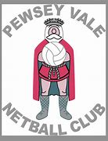

The Pewsey Netball Post
Newsletter
Jan 2022

Newsletter Pewsey Vale Netball Club www. www.pewseynetball.co.uk

Facebook: Pewsey Netball Club Email: pewseynetball@gmail.com

HAPPY NEW YEAR

Contents:
- Foreword from Club chair
- Captain’s words
- Club survey results
- Officiating secretary update
- Update from treasurer
- Training Secretary
- Equipment & Kit Secretary
- Social events
- Covid 19 update

Foreword from club chair

Emily Hues.

Happy New Year to you all. Both Pewsey Blacks and Pewsey Reds have had strong starts in the Moonraker league. All players have been working hard during training which is being rewarded during matches.

Following a recent survey we've made changes to our training structure so thanks all for your feedback and support with this. Please do continue to pick up a whistle at training.

We've welcomed several new members since the season started and more in January. It never ceases to amaze me the number of new people coming through our doors!

A highlight for me so far has been the restarting socials, it's what Pewsey Netball Club is all about! I'm looking forward to more to come and the return of the Spain tour.

As always, any suggestions do get in touch.

Captain’s Words
Team Black
Rio McQueen & Cerys Perkins

A good start to the 2021-22 season for Blacks. There has been good attendance at training, and we have had 4 wins from 4 games. Player of the Match has been awarded thrice to Lauren and once to Liv. Unfortunately, one game was cancelled due to cold weather and is rescheduled for February. We faced Chippenham who are currently at the top of the league. And won by 1 goal! Congratulations to Chloe who got married in December.

Team Red
Ruth Hobbs

A great start from team Red, second in the league and playing well. Division 3 is tough this year and teams have obviously used the time off from covid to prepare. Massive congratulations to Alice and Kala on their exciting news and welcome to Jodie and Emma, who step into the Reds team. We have our first game of the season on the 20th Jan and we are hoping to continue our winning streak. Focus: zonal marking and communication.
Team White
Ruth Hobbs

Due to the complications of covid, Team White have only managed one match so far this season, but we are hopeful that this will increase as the season progresses. Many thanks to Kala for organising the match against Queen’s at Pewsey rugby club. Pewsey fought hard and were winning until their opponents brought on a strong player, who swung the result in their favour. Everyone played well with POM going to Jodie.

Club survey results

Written by Emily Hues
Thank you to all those that took the time to give feedback during the recent survey. The committee met and have been reflecting on the responses and changes we would like to make.
Key points
Training – Players would like more coaching during match play. The session focus could be taken into the match play. Time to be given to tactics for eg set plays, back line passes, centre pass, zoning etc. Drills to be progressed and players to remain focused.
Changes proposed – starting the session. We will be starting the session by meeting in the centre third, introducing new players and making any announcements. Drills. Trudie will communicate the focus and this will be followed through into match play. We will be doing more whole club team games for warm up and drills. Match play. This will be stop start, to give feedback to players. Players are encouraged to umpire as Trudie will be coaching, not umpiring. Each team will have a focused time, where positions will be prioritised to that team, other teams will support when they are not the focus – this could be by umpiring, coaching, cheering etc.
Matches – On the whole feedback was positive. Captains should be mindful of time on court and ensure this is shared more fairly where possible.
Overall – It was recognized that Pewsey is a special club, we are friendly and inclusive and long may we be so!
Umpiring session: We will have a training session focused on umpiring. If anyone is interested in a formal qualification, please ask Sarah our umpiring secretary for details.

Officiating secretary

Sarah Mills
I can start the New Year off with some very good news. Congratulations to Emily who passed her practical umpiring assessment on Tuesday 11 January. She is now an England Netball ITO qualified umpire!
We are very lucky this season to have so many umpires with a broad range of experience that are all helping to cover our umpiring commitments in the league. For those who don’t know, we have:
Ella – C award, working towards her B award
Trudie – C award
Monica – C award
Zoe – C award
Ruth – C award
Emily – ITO (Into Officiating) award
Sarah – working towards ITO award.
We are always looking to support and encourage more players to get involved with umpiring, both informally at training and through the England Netball Officiating Pathway. For more information about the latter, please go to https://www.englandnetball.co.uk/get-involved/officiating.
The club can financially support players who wish to undertake the EN training as we need umpires to enable us to play. We are currently waiting for EN to release more dates for the theory ITO courses and I will let you know when I hear. These courses are now carried out virtually via zoom and consist of two 2-hour sessions aiming to introduce you to the rules of the game and the basic principles of officiating.
The club is also planning to incorporate an umpiring session at training. The aim of this is to improve everyone’s awareness and appreciation of the umpiring role and to help all players feel more comfortable to pick up the whistle at training and help umpire during match play.
If you are interested in ITO courses or just want to find out more about umpiring, please do chat to any of our umpires and/or have a chat with me so that the club can support you with your umpiring goals!

Update from treasurer
Elaine Haynes
Thank you to everyone for paying your subs on time, you make my job easy, thank you! To play competitively, you need to be registered with All England Netball Association (National Governing Body for Netball). You need to do this individually via the EnGage website https://engage.englandnetball.co.uk/ and the cost is £43.
The cost of membership for PVNC is £15 annually, this is payable in September or whenever you join.
If you join part way through the season the charge will be £20 per month, and you can choose to pay either monthly or in one installment.
There is an option to “pay as you play” at £8.00 per session.
There is also a cost for matches of £1 per quarter played, which covers the cost of the umpires. I will send out monthly messages to players with payment owed. Please ensure you pay within two weeks of the invoice and check the PVNC Payment policy for more information.

Training secretary

Hanna Daw

We have seen good numbers at training and as per the results of the survey that were sent out, we have made some updates to the format of training sessions. These may take a few weeks to bed in; however, we hope you find the structure more beneficial to all.
Training kit will now be collected and returned by either reds or blacks on alternate weeks. The codes for the secure area and lockbox are pinned on Facebook and WhatsApp groups.
Finally new to 2022 we are introducing player progress plans. This is open to all players if you wish to participate and will allow for individual feedback from Trudie with the aim to encourage and develop players. More information to follow
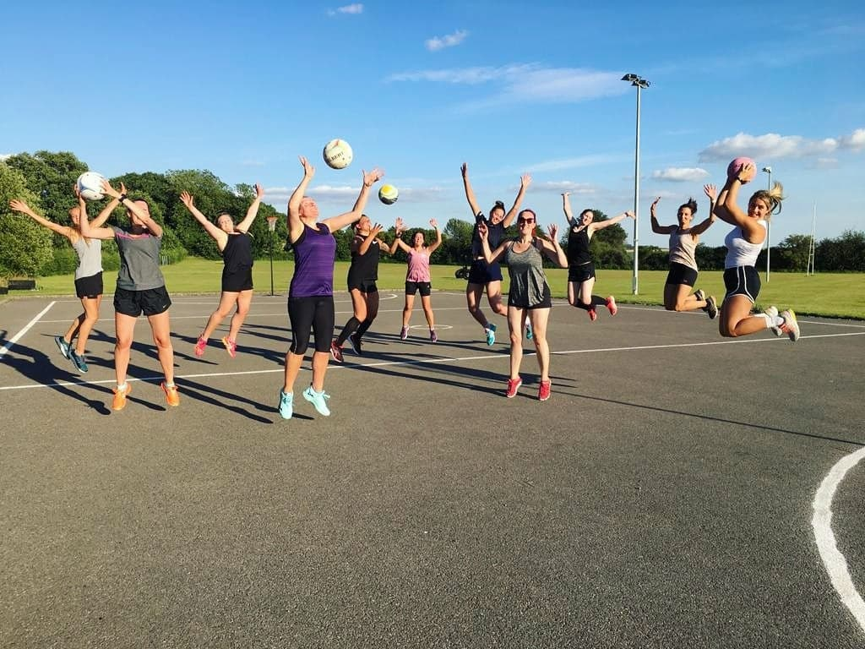

equipment and kit secretary

Sarah Mills
We have recently received the new dresses that were ordered. It was a bit tricky this season as the company we have previously used appears to have ceased trading, so we had to not only find a new supplier but had to try and match the design to our current ones. Many thanks to Karl, Kelly’s Husband, who helped us with this and got us a very competitive price on the order. The new dresses look fabulous!
It works out quite expensive to order new dresses individually, so for any new players who join the club during this season who need a dress to play in league or friendly matches you are able to hire a dress from the club. We ask that you pay a fully refundable £20 deposit for the dress. This will be returned to you when you return the dress to the club.
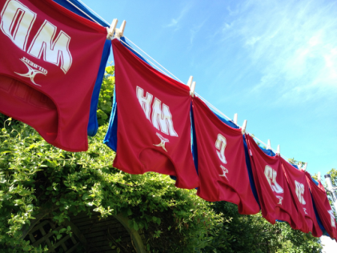
We do have an online kit shop with Kukri. A selection of items including training t-shirts, leggings, hoodies, coats and tracksuit bottoms, all with the club logo are available to order whenever you want. You can also personalize items with your name or initials when you order. Please find the online kit shop at: https://www.kukrisports.co.uk/teamshop/pewseynetballclub/productNavListNg.action
We have been trying to arrange for a Kukri representative to come out to see us and bring kit samples to one of our training nights, so that people can see the kit and also try out sizes. The main difficulty with this has been Covid making it difficult to arrange sessions where items can be tried on by multiple people. I will keep you updated.

Social events

Kala Haynes
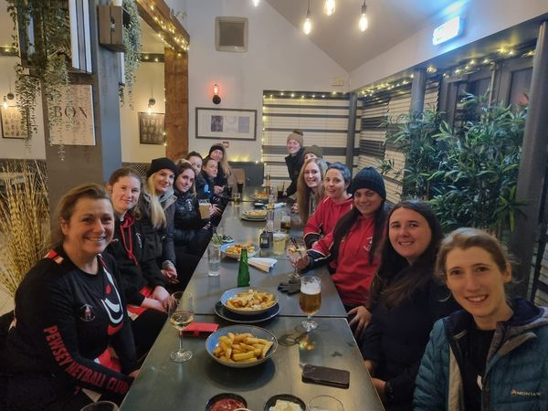

We have had many social events so far this season and are looking forward to many more! Highlights include a curry night, the Rugby ball, a meal in Marlborough and a trip to the Copperbox to watch the Roses in action. We have some exciting things coming up, so please do keep an eye on the Facebook members page, to name a few:
- Netball tour to Spain,
- Netball tour to Wales
- Coaching session with the one and only Serena Guthrie
- and the possibility of some walking events to keep us fit while we natter!

Please speak to me or a member of the committee for more details.

Covid 19 update

Sarah Mills
EN continue to monitor and amend their guidance. I am kept up to date about this via email and by checking the EN guidance online, https://www.englandnetball.co.uk/about/covid-19-support. Hanna also recently attended a virtual covid update forum to make sure that PNC is following all the latest guidance.
We continue to follow the guidance, as follows:
- Self-assessment before attending any netball activity – If you have any COVID-19 symptoms (high temperature, a new continuous cough, a loss or change to sense of smell or taste) please do not attend netball and take a COVID-19 test as per Government guidance.
- It is advised that people take regular lateral flow tests (LFT) and, as a club, we recommend that you undertake an LFT before attending netball activity. If you have a positive LFT please do not attend.
- Self-isolation – do not attend any netball activity if you are required to self-isolate.
- Social distancing where possible when not on court
- Hand hygiene – use of sanitiser for hand hygiene pre and post netball activity and at regular/appropriate intervals during play. The club will provide sanitizer but please, where possible, bring your own.
- Items such as water bottles and whistles should not be shared.
Everyone has been so good at following the rules and by continuing to follow all the guidance at the club, we can help to reduce the risk of transmission, but the nature of the netball game is such that a risk remains. Everyone on court, whether that be at training or at a match, is classed as a close contact. If you have been fully vaccinated you are exempt from the requirement to self-isolate if you are a contact of a positive case, however you are currently advised to take a lateral flow test as soon as possible. For those who are not fully vaccinated it is a requirement to follow government self-isolation guidance.
Please remember to notify me if you test positive within 48 hours of attending Pewsey netball club activity.
As always, if you have any queries, questions, or concerns with regard to Netball and Covid please do not hesitate to get in contact with me.

Finally....
A big welcome to new members and don’t forget to join our Pewsey Vale Netball Members Facebook page, where we keep you up to date with all thing’s netball!

Parents/players/supporters, if you would like to become more involved in the club, either in coaching/captains/website/advertising etc, please do let us know, as volunteers are always welcomed!!!! You do not need to know much about Netball…… It could even be a matter of updating the results on the website…… you can pick it up as you go along!!!!

Best regards,

Pewsey Vale Netball Club

