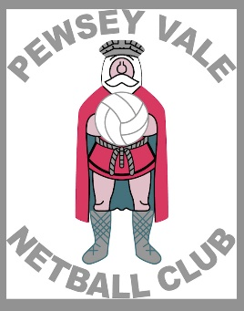
Pewsey Vale Netball Club
Club Vision and Team Selection Procedure 2023

Club Vision
We aim to provide the best opportunity for each player and our teams, enabling them to maximise their playing potential. Our core values as a club are: sportsmanship, respect, commitment and team and club spirit. We want to provide a quality sporting and social environment for all. Our local community is important to us and we endeavor to organise social and charity events throughout the year. We are a competitive club, we aim to win each match but are gracious in defeat, understanding that progression is more important than perfection.

Club aims
To increase participation and develop the future of netball, building strong relationships within the club and the community.

Team selection
Teams will be selected prior to the start of the season by a selection panel.

All members should strive to attend all trial sessions. However, we understand family and work commitments take priority. You must inform the committee if you are unable to attend trials and still wish to be selected for a team.

Captains & match team selection
Captains will be selected by a vote, from the respective team after putting themselves forward for the role or after being approached by the committee.

Starting 7 players will be selected for each match by the captain with assistance from the coach and or vice-captain. We aim for all players to play equally each match but as a competitive club we understand this may not always be possible every game, depending on the situation.

Training
All members should strive to attend all training sessions. However, we understand family and work commitments take priority.

If you are unable to attend training or matches, in the absence of an emergency, you should inform your captain or the committee at least:
- 24 hours before training
- 72 hours before a match (to allow a replacement to be found)

We are a social club and many social events are organised throughout the calendar year. Anyone is able to suggest ideas or organise events, contact the social secretary.

