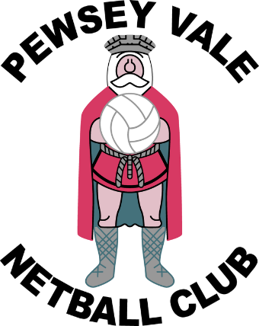
Pewsey Netball Club Fixtures – Moonraker Summer League 2019

Day | Date | Time | Home | Away | Court
Thursday | 6th June | 7pm | Pewsey in the Park | Calne | 3
Thursday | 6th June | 8pm | Pewsey in the Pool | Devizes Bikinis | 2
Becka Umpire: 7pm Chip 2 vs Melksham Hokey Pokey Court 2
Sarah Umpire: 8pm Chip 3 vs Devizes beach balls court 3

Thursday | 13th June | 7pm | Pewsey in the Pool | Chippenham 2 | 2
Thursday | 13th June | 7pm | Pewsey in the Park | Chippenham 3 | 3
Becka Umpire 8pm: Melksham Hokey Pokey Devizes Bikinis court 2
Sarah Umpire 8pm: Calne vs Holt court 3
Thursday | 20th June | 7pm | Pewsey in the Park | KSM | 3
Thursday | 20th June | 8pm | Pewsey in the Pool | Melksham Hokey Pokey | 3
Becka Umpire 7pm: Chip 2 vs Devizes Bikinis Court 2
Sarah Umpire 8pm: Calne vs Chip 3 Court 3
Thursday | 27th June | 7pm/8pm | Pewsey in the Pool  Pewsey in the Park  Knock out rounds – To be advised
Sarah Umpire: tbc
Becka Umpire: tbc
Thursday | 4th July | 7pm/ 8pm | Pewsey in the Pool  Pewsey in the Park  Knock out rounds – To be advised
Sarah Umpire: tbc
Becka Umpire: tbc
Thursday | 11th July | 7pm / 8pm | Pewsey in the Pool  Pewsey in the Park  Knock out rounds – To be advised
Sarah Umpire: tbc
Becka Umpire: tbc

All matches are played at Devizes Leisure Centre, Southbroom Road, Devizes, Wiltshire SN10 5AB.
PARKING is available in the car parks behind the Leisure Centre.
Please arrive 15 minutes before the match time stated above ensuring nails are cut, hair is tied back and all jewellery is removed.

